|  |  |  |
| --- | --- | --- |
| **Module Code**  **COMP5850M** | School of Computing  University of Leeds  **Coursework 1 - Report** | University of Leeds logo |

Full Name: Username:

Coursework Title: VIM Deadline Date: 09/03/2020

**Part 1: Java OpenNebula Cloud API (OCA) (10 marks)**

*Provide an explanation of the implementation of this task. The inclusion of the entire code is not required but you may include snippets if you wish.*

*VM template (1 mark)*

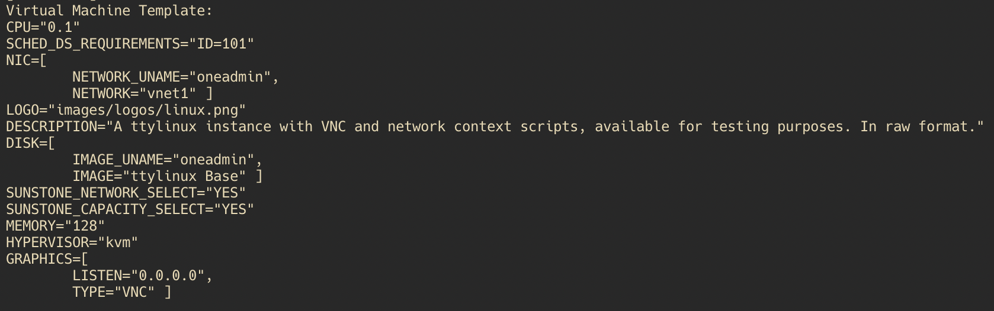

*Information OpenNebula provides about the VM (1 mark)*

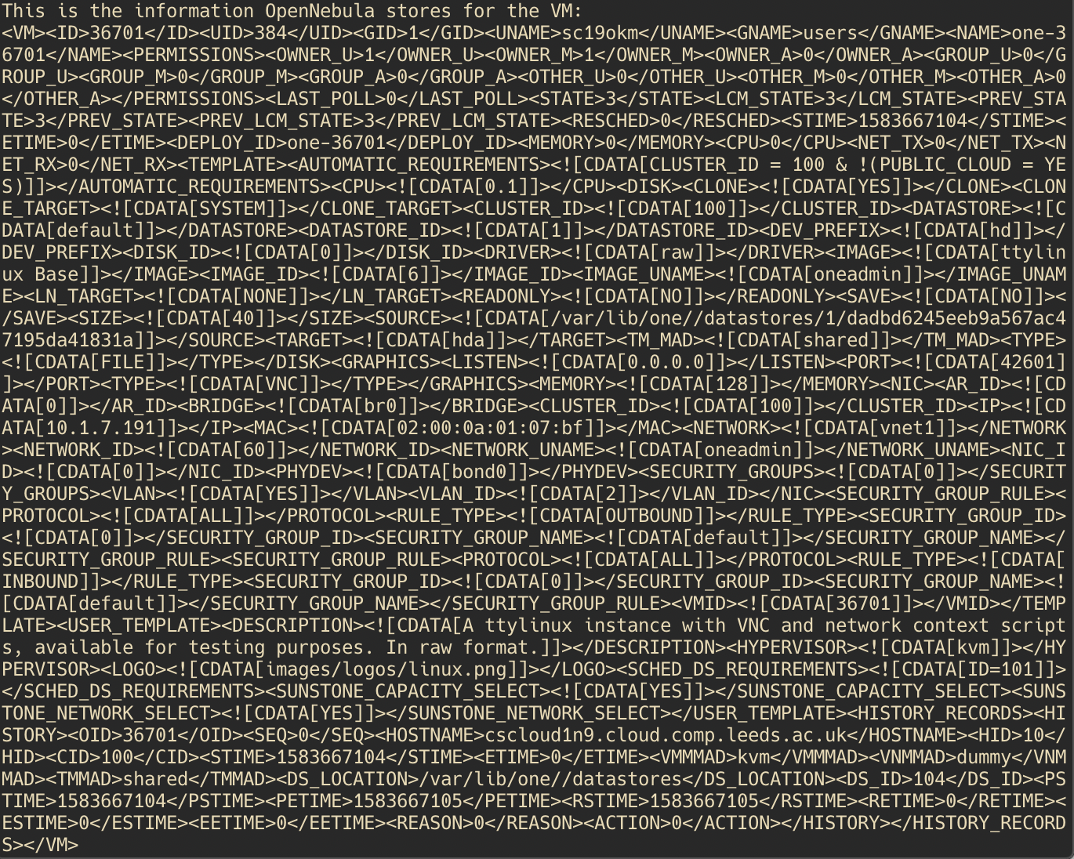

*Measure the time it takes to instantiate/delete the VM. To get these measurements you are expected to run the experiments n times (e.g. n = 5). A statistical analysis (average, standard deviation) is expected. (2 marks)*

|  |  |  |
| --- | --- | --- |
| **Run No.** | **VM instantiation time** | **VM deletion time** |
| **1** | 3957 | 8 |
| **2** | 3614 | 8 |
| **3** | 3352 | 5 |
| **4** | 3550 | 6 |
| **5** | 3325 | 6 |
| **Average** | 3559.6 | 6.6 |
| **Standard Deviation** | 227.645865 | 1.2 |

*Explain how you have obtained these measurements (2 marks)*

To calculate how long the instantiation took, I have first allocated the virtual machine, using vm.allocate(). After allocation, I deployed to a host that I chose arbitrarily, which was 10 in my case. After deployment, I then wrote a loop where the system waits for the virtual machine to reach the state running, which OpenNebula has coded as “runn”. If the machine is not yet running, it waits for 10ms before trying again. I added a sleep call, as it shouldn’t affect the time too much, whilst also sending less requests to the API asking for VM info. After making sure that the VM is running, the time can then be recorded, from before allocation to the point where the VM is running. The code for the while loop looks like this:

while (!vm.status().equals("runn")) {  
 Thread.*sleep*(10);  
 rc = vm.info();  
}

As for deleting VM, the call is much more simple, as I made an assumption that the VM being deleted is already running. In that case, a simple vm.finallizeVM() call is needed. The measured time is the time it took the call finalizeVM() and return a response.

*Evidence of successful run, e.g. screenshot (4 marks)*

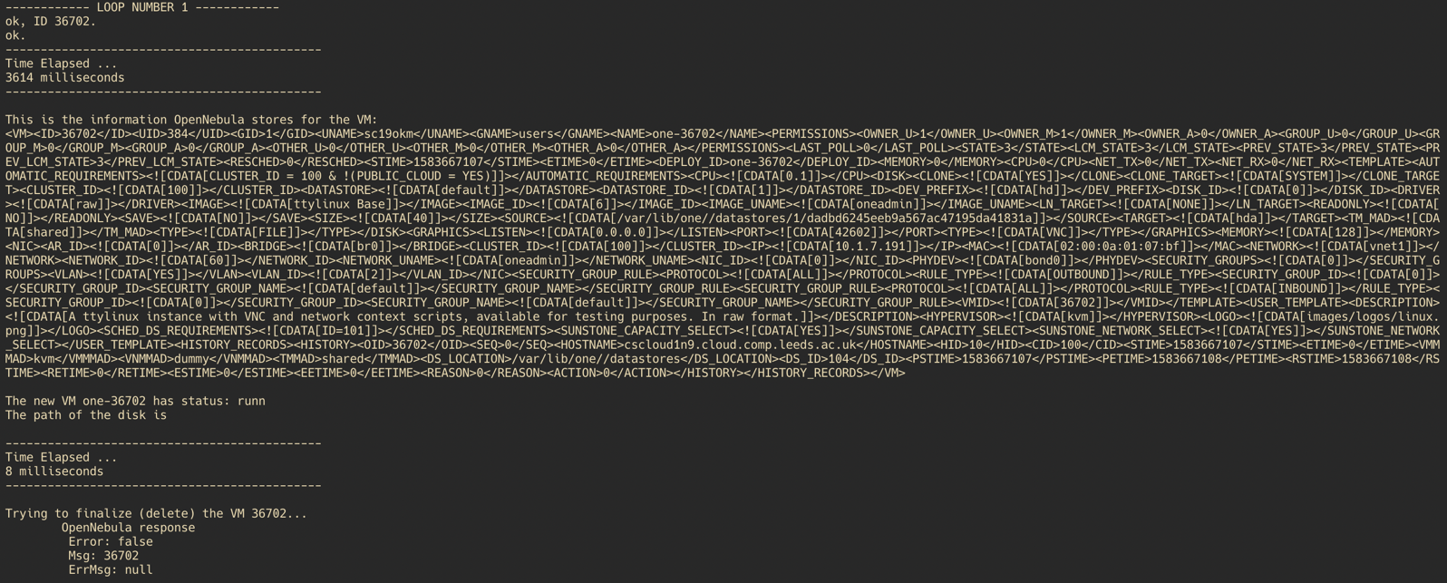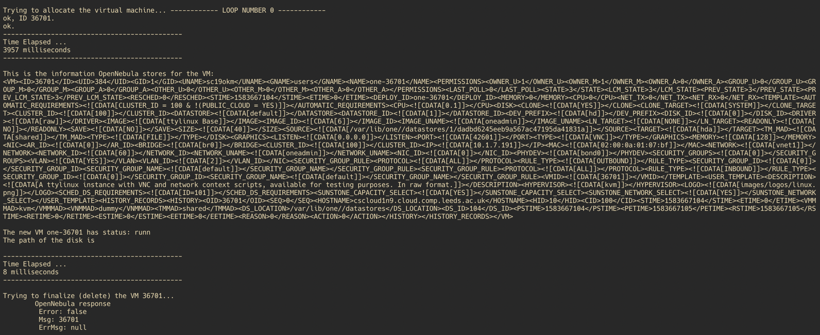

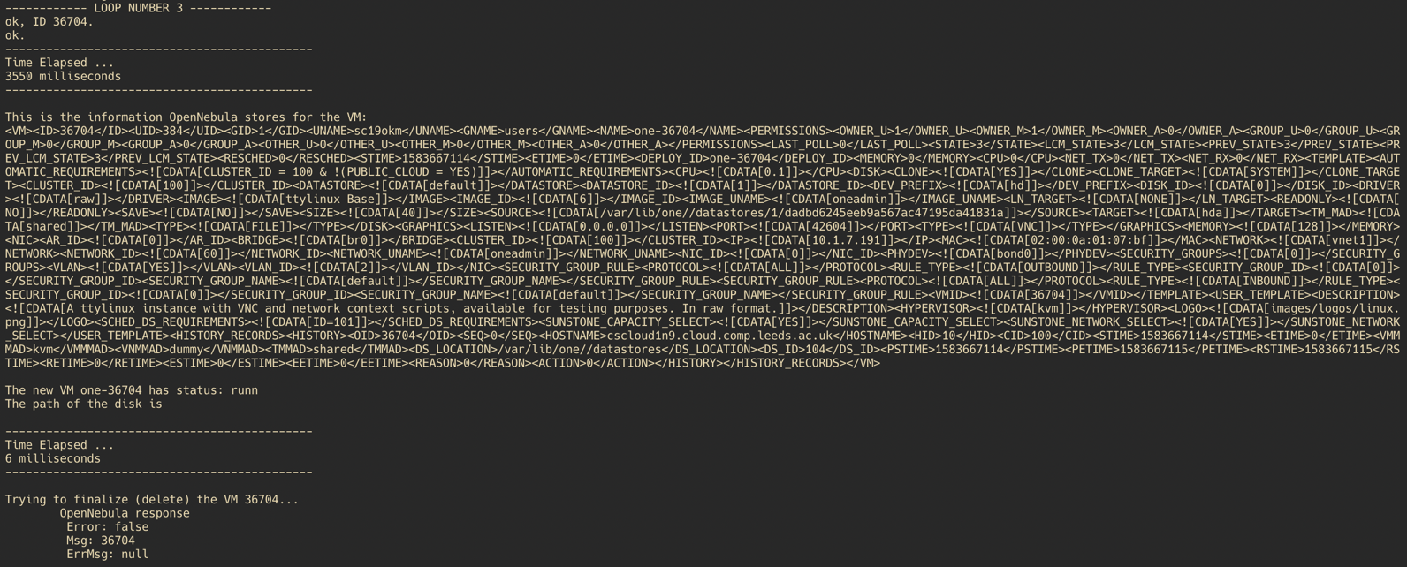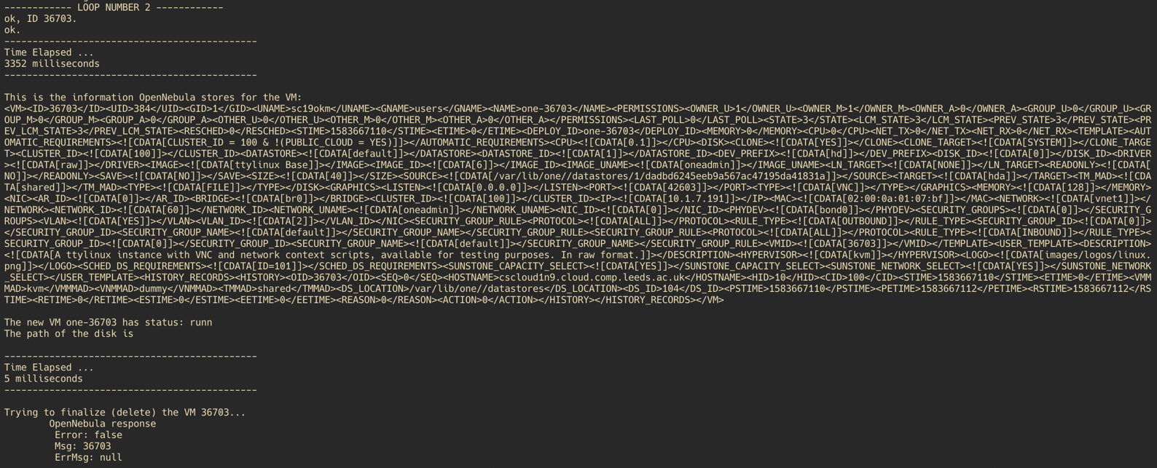

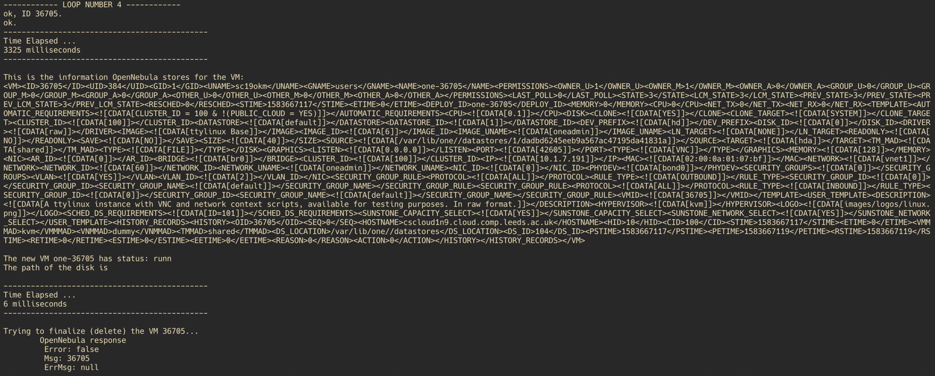

**Part 2: VM Migration (15 marks)**

*Provide an explanation of the implementation of this task. The inclusion of the entire code is not required but you may include snippets if you wish.*

*Requirements (2 marks)*

The solution needs to successfully migrate a VM to a different host, based on a heuristic. I have made an assumption that the VM is resource-heavy and requires to be moved to a host which has the least CPU usage, memory usage and disk usage. This is calculated using ‘weights’ that represent the importance of each resource. If a resource has higher weight, then the calculation will favour that resource being lower than the rest.

*Solution Design (2 marks)*

The objectives of these experiment is to see how quickly the solution migrates the VM, especially comparatively to initialisation of the VM. If the VM initialises, deletes and then initialises again quicker, then there is little point in migration. The first task however is to design a way that the VM should migrate. As described before, I will design the solution to take the various resources of the host and check how much load they are under. This can be done using weights, where all of the values are between 0 and 1, and they must add up to 1. For this experiment, I assumed the VM is more CPU/Memory intensive, with CPU taking slight precedent, therefore I set the weights to [0.5, 0.4, 0.1] for CPU usage, memory usage, and disk usage respectively.

The overall structure will rely on getting host information first. This can be done quite easily by OpenNebula API. Once the information is retrieved, it can be stored in a data structure like an array, or a map. Then the minimum value is retrieved along with the host id. Then migration can be done quite easily by a single function call. Migration isn’t a single process, and it requires the VM to go through several phases, such as save etc. Therefore, to properly time the migration, there needs to be a loop, similarly to part I, which waits for the migration to fully complete, and the VM to be running.

*Implementation (2 marks)*

Firstly, I have initialised the VM as in part I, using vm.allocate() and then vm.deploy(). Next, for the migration to be successful, I need to get information about the host, which can be done by a simple call to the API asking for a HostPool. A pool is a data structure holding all the hosts, therefore, it can be looped, retrieving all the hosts. The hosts’ information can then be easily accessed through getters and host.xpath().

Also, in the same call, it is quite easy to calculate the ‘validity’ of the host for the new VM, by calculating the heuristic. The math is quite simple, as a set of weights are stored in an array, which are then multiplied by the respective resource usage. The sum of the weight * resource usage is then calculated. Resource usage is calculated through current resource usage divided by max resource usage. Once the heuristic has been calculated, it can be stored in a HashMap. I used a HashMap as it provides a quick way to store an id, alongside its heuristic value. Finding the minimum is also easy in Java, as it’s a single line of code. My code, therefore, looks like this:

private void getHostInfo(){  
 // CPU MEM DISK  
 double[] weights = {0.5, 0.4, 0.1};  
  
 double cpuUsage, memUsage, diskUsage;  
 int hostId;  
  
HostPool pool = new HostPool( oneClient );  
pool.info();  
  
 System.*out*.println("Physical Hosts with resource usage:");  
 System.*out*.println("-----------------------------------------------------------------");  
 System.*out*.println(String.*format*("|%-15s|%-15s|%-15s|%-15s|", "HOSTID", "CPU USAGE", "MEM USAGE", "DISK USAGE"));  
for( Host host: pool)  
{  
 rc = host.info();  
 cpuUsage = (Double.*parseDouble*(host.xpath("/HOST/HOST_SHARE/CPU_USAGE"))/Double.*parseDouble*(host.xpath("/HOST/HOST_SHARE/MAX_CPU")))*100;  
 memUsage = (Double.*parseDouble*(host.xpath("/HOST/HOST_SHARE/MEM_USAGE"))/Double.*parseDouble*(host.xpath("/HOST/HOST_SHARE/MAX_MEM")))*100;  
 diskUsage = (Double.*parseDouble*(host.xpath("/HOST/HOST_SHARE/DISK_USAGE"))/Double.*parseDouble*(host.xpath("/HOST/HOST_SHARE/MAX_DISK")))*100;  
 hostId = Integer.*parseInt*(host.xpath("/HOST/ID"));  
 double heuristic = Math.*abs*(cpuUsage) * weights[0] + Math.*abs*(memUsage) * weights[1] + Math.*abs*(diskUsage) * weights[2];  
 hostMap.put(hostId, heuristic);  
 System.*out*.println(String.*format*("|%-15s|%-15s|%-15s|%-15s|", Integer.*toString*(hostId),  
 String.*format*("%.2f", cpuUsage), String.*format*("%.2f", memUsage), String.*format*("%.2f", diskUsage)));  
}  
 System.*out*.println("-----------------------------------------------------------------");  
  
 }

I have wrapped the various resource usages in Math.abs() because of the strange errors the OpenNebula API sometimes returned, where the max resource usage was negative. Finally, the migration can be achieved using the following:

private void migrate() throws Exception {  
  
Integer id = Collections.*min*(hostMap.entrySet(), Map.Entry.*comparingByValue*()).getKey();  
System.*out*.println(String.*format*("MIGRATING TO HOST %d AS IT HAS THE LOWEST HEURISTIC VALUE OF %.2f", id, hostMap.get(id)));  
  
 rc = vm.migrate(id);  
  
 rc = vm.info();  
  
 while (!vm.status().equals("runn")) {  
 Thread.*sleep*(10);  
 rc = vm.info();  
 }  
 }

The while loop is necessary to ensure that the VM has fully migrated. And, finally:

private void part2() {  
 try {  
 connectToClient();  
 printTemplate();  
 for (int i = 0; i < 5; i++) {  
  
 System.*out*.println("------------ LOOP NUMBER " + i + " ------------");  
  
 initializeVM();  
  
 long startTime = System.*currentTimeMillis*();  
  
 getHostInfo();  
 migrate();  
  
 long endTime = System.*currentTimeMillis*();  
 long elapsed = endTime - startTime;  
 System.*out*.println("---------------------------------------------");  
 System.*out*.println("Time Elapsed ... ");  
 System.*out*.println(elapsed + " milliseconds");  
 System.*out*.println("---------------------------------------------");  
  
 printVMInfo();  
  
 }  
 } catch (Exception e)  
 {  
 System.*out*.println(e.getMessage());  
 }  
}

*Measure the time it takes to migrate the VM. (2 marks)*

|  |  |
| --- | --- |
| **Run No.** | **VM migration time** |
| **1** | 2594 |
| **2** | 2379 |
| **3** | 2510 |
| **4** | 2345 |
| **5** | 2428 |
| **Average** | 2451.2 |
| **Standard Deviation** | 101.092532 |

*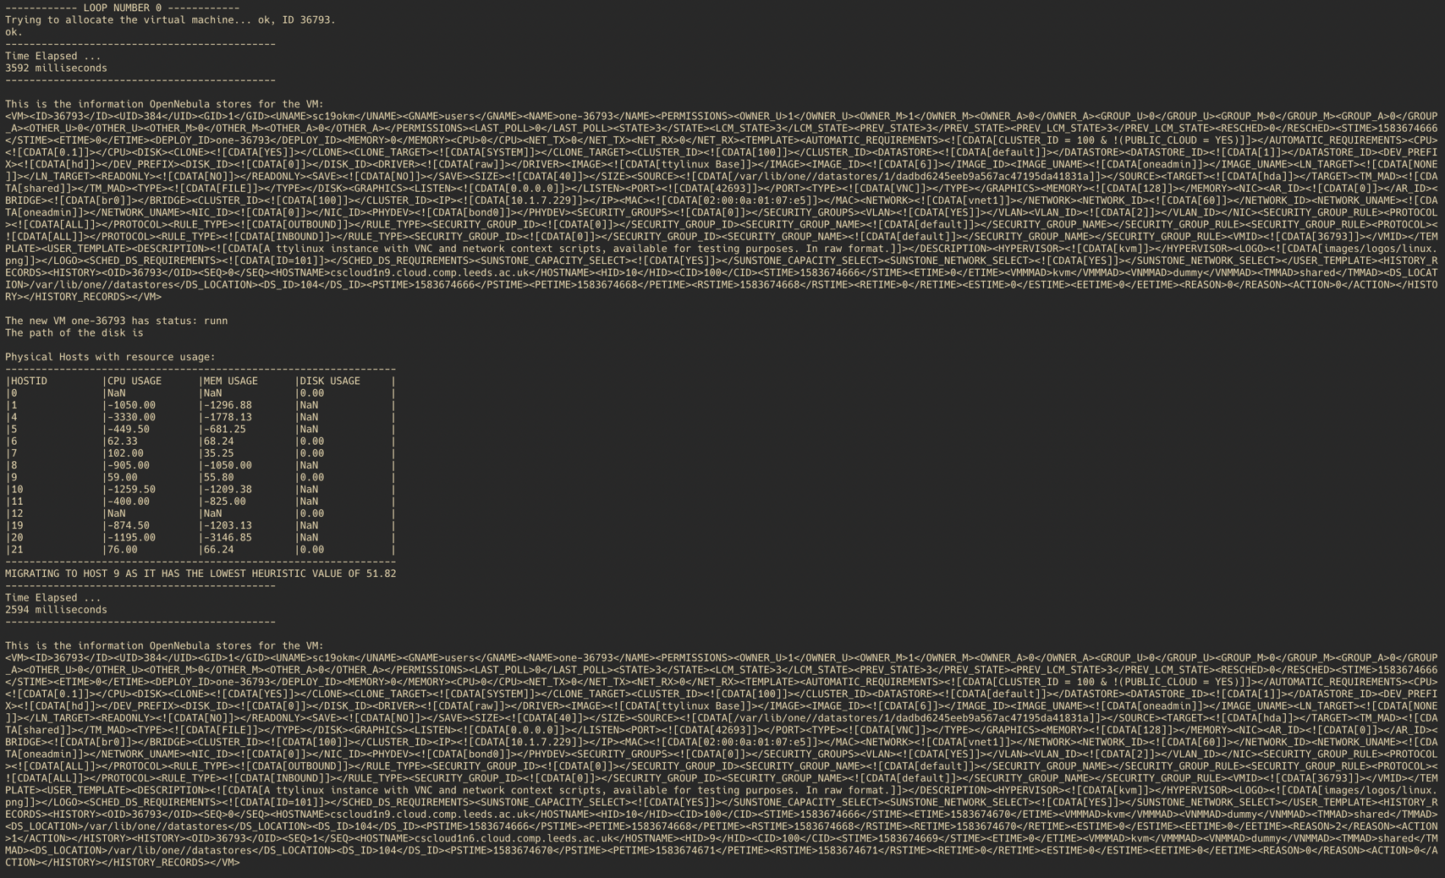Evidence of successful run, e.g. screenshot (3 marks)*

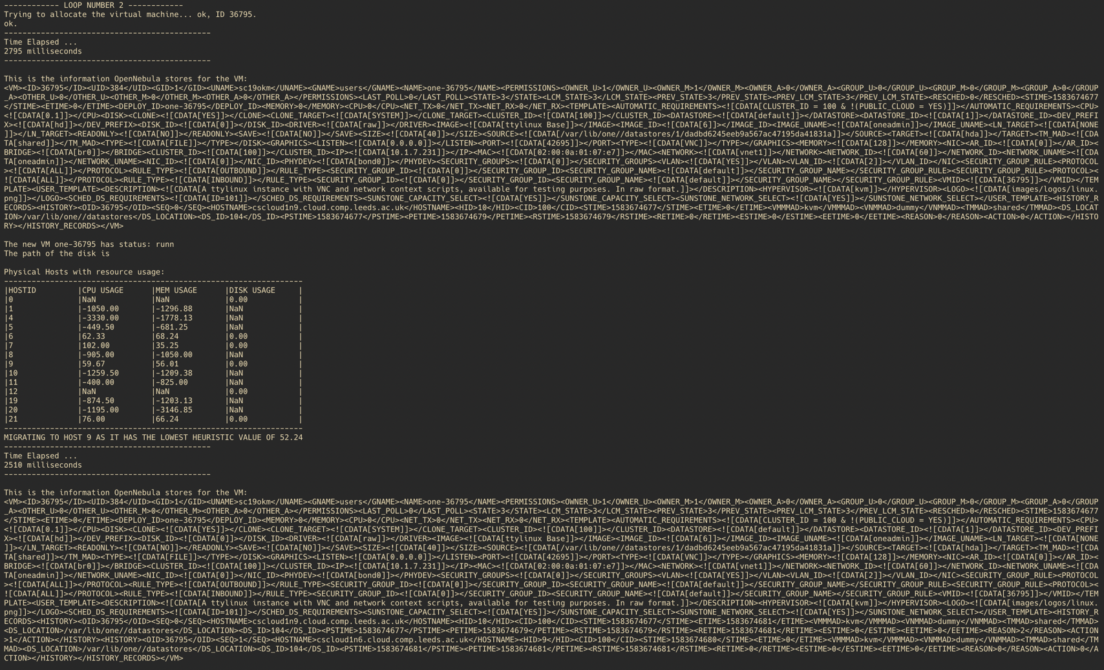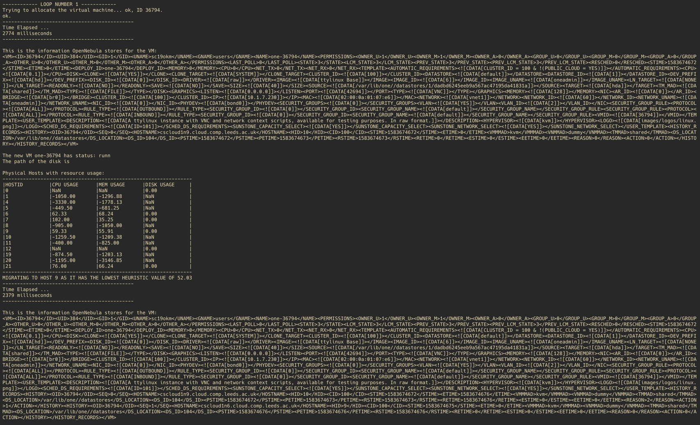

*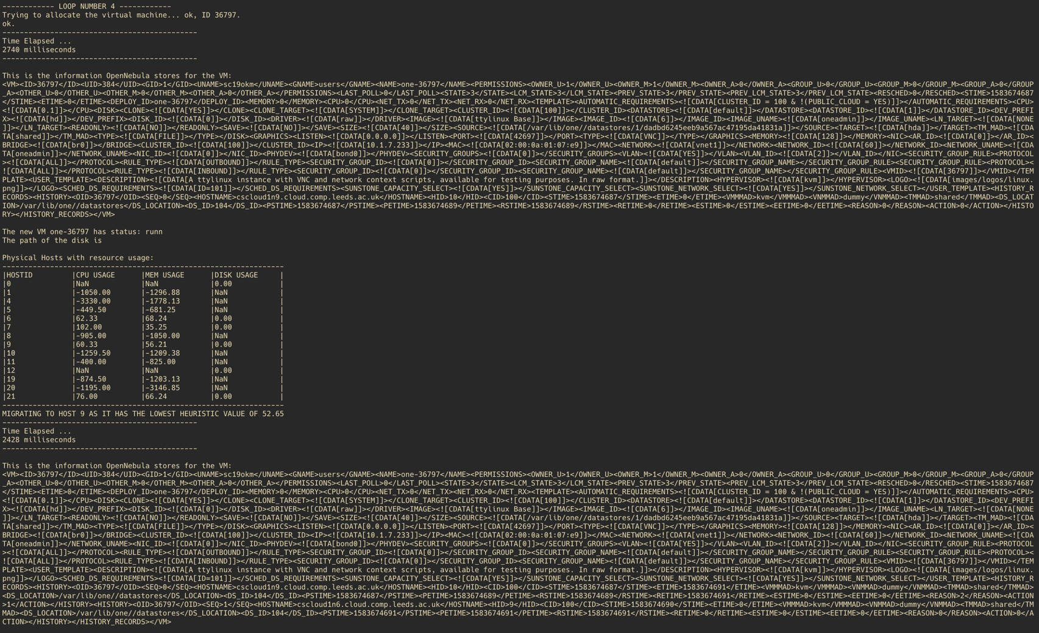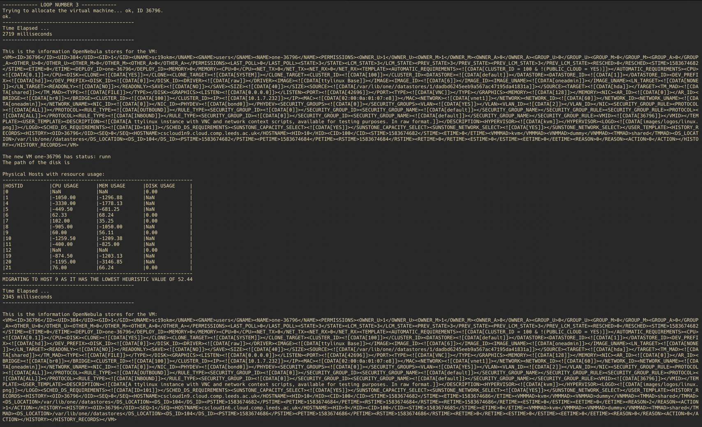Discussion of the results (4 marks)*

The results were somewhat expected as migration took considerably less time than the initialisation of the VMs. However, the information could be wrong as OpenNebula API returned strange values for usage, due to being overloaded. This, however, hasn’t impacted my migration too much, apart from ignoring the machines with incorrect values, so these machines were not considered for migration, nor should they. As you can see from the screenshots, the heuristic kept rising in value, as more machines were initialised therefore bigger load. Despite that, the algorithm managed to successfully migrate to the host with the least load, namely host 9 at the time of the experiments.

The results can be somewhat misleading, as there wasn’t many valid options for migration, as my algorithm relied on host information, which the API sometimes returned invalid values. Thus, there were possibly 2-3 machines that the algorithm could reasonably chose.

Despite the issues, the heuristic value rises over the number of experiments. This is because the VMs were not deleted with each initialisation, therefore the load of the host went up throughout the experiment. However, since the other machines were still more overloaded than host 9 at the time, the migration went for host 9 every time.

From the VM information XML, it can be clearly seen that another entry has been added to the XML, namely a list of previous hosts, along with the current one. The current host can be seen as the one with the highest ‘SEQ’ number.

Generally speaking, it can be seen that my algorithm has successfully managed to work, despite the unfortunate issues within the OpenNebula API. Therefore, my algorithm is error tolerant, and allows flexibility from a user to define what is best for the application and get the best VM performance. One issue with my algorithm is that it does not take energy consumption into account, so it’s not inherently cost efficient.

**Part 3: Resource Scaling and Performance/Energy Consumption Trade-Off**

**(10 - 25 marks, depending on application and challenge)**

*Details of the application considered (stress, MPI, Hadoop, other) (1-3 marks)*

I have decided to use Hadoop, which is an implementation of the MapReduce framework. I have used Hadoop on the virtual machines that were deployed, along with the temperatures that were used in the Hadoop example. I have decided to concatenate all of the years into one huge file, measuring at 450MB. I have also used appropriate Java code to give to Hadoop for the process to yield the correct results.

*Design of the experiments (1-4 marks)*

The objectives of the experiments is to test how different number of virtual machines affect the time that the application needs to run, along with any power/cpu usage spikes. The experiments consist of first running a Hadoop job on a single host with a single machine. Then, after some configuration, for the Hadoop job to run on 2+ VMs on a variety of host/VM arrangements. Testing different arrangements is really where the experiments will be the most helpful in understanding the underlying requirements of the application.

The times of the Hadoop jobs can be measure via a Linux command or some other way, whilst other statistics, namely those about power and cpu usage can come from Zabbix, a tool that helps monitor usage on host.

The jobs can be run multiple times to see how it affects the load of the host, along with gathering more accurate data about the experiments. This isn’t very difficult to do, as it can be accomplished through a simple bash script with a loop. Once the experiments are run statistics about the hosts through Zabbix can be acquired. This can be done for all the different arrangements. The different arrangements that I will be testing are: 1 host hosting 1 VM, 2 hosts hosting 1 VM each, 1 host hosting 2 VMs, 2 hosts hosting 2VMs each, 4 hosts hosting 1 VM each, and finally, 1 host hosting 4 VMs. This is a very steady increase in VMs and hosts, which should give an accurate idea of how the application scales with hosts and VMs.

*Implementation of the experiments (1-4 marks)*

First, I have initialised all of the VMs and named them accordingly. I created a Master and Slave 1, 2 and 3. I have also created a separate VM just for the single VM/host case, as that requires slightly different config. This was all done through the OpenNebula’s portal called Sunstone. In both cases I used the same template to create VMs with, which was the provided ‘Debian Stretch (Hadoop)’ template.

Once I have created the VMs, I have started configuring a VM for the single host single VM case. Firstly, I had to create a user named ‘hduser’ and create ssh keys. This was so that when Hadoop wanted to communicate with it’s datanodes, it didn’t require a password every time. Then, I had to configure the machine so that all the dependencies were correct, this meant configuring the right Hadoop Java dependencies such as $CLASSPATH, and the correct path to Java jars. This meant configuring .bashrc.

Once the Java configuration were correct, I needed to configure Hadoop’s configuration files. This meant setting the right namenode, defining data notes, local directories, and number of replications. The files that I configured were core-site.xml, mapred-site.xml, hdfs-site.xml and finally yarn-site.xml. Once the configuration was complete, Hadoop services could be started using start-all.sh, and the data could be copied to Hadoop’s file system HDFS. I have gotten my data from from csgate1.leeds.ac.uk:/home/cscloud1_data_a/storage/scskd/data/noaa/all. This directory contained data about temperatures, which were split between years. I combined all of the temperatues by unzipping the files and then using the command ‘cat 20* >> all_temperatures.txt’. I have then copied the data into HDFS using ‘hdfs dfs -copyFromLocal all_temperatures.txt data.txt’.

Lastly, Hadoop needed a compiled application that defines how the map and reduce process should work, which I also got from csgate1. The code, however needed to be compiled first using ‘javac *.java’ and zipped into a jar using ‘jar cf MaxReduceJob.jar .’. Once I had the jar, Hadoop can start the job. However, Hadoop only shows time took for the individual stages, therefore I had to use GNU’s time command to time how long the entire job took, and output the time to a file. I did that using this shell script, which also repeated the job 5 times:

#!/bin/bash

for i in {1..5}

do

command time -ao 1h1vm_each_times.txt hadoop jar ~/code/org/myorg/MaxReduceJob.jar MaxTemperature data.txt 1ph1vm$i

done

Extending this to work with multiple nodes was not hard, as it required slight changes in Hadoop config files to no longer link to localhost, but instead to a static IP representing the master. The clients needed the same config files as the master, along with the same .bashrc, linking Java dependencies correctly, and ssh keys to make communication between the nodes easy. To define which VMs were being used, I had to change Hadoop’s ‘workers’ file that contained each VMs IP address, so that the master knew how to communicate with the other machines.

To test different host layouts, I could use OpenNebula’s Sunstone to easily migrate the VMs so that they obeyed the experiment’s required architecture, and then ran the required job as before. For the master/slave communication, I have never turned any VMs off, instead, if I wanted more/less slaves, I changed the ‘workers’ file in Hadoop’s configuration files and removed/added any required IP addresses.

*Discussion of results (3-10 marks))*

**Results of Hadoop Jobs**

|  |  |  |  |  |  |  |
| --- | --- | --- | --- | --- | --- | --- |
| **Run No.** | **1 Host with 1 Virtual Machine** | **1 Host with 2 Virtual Machine each** | **2 Host with 1 Virtual Machine each** | **4 Host with 1 Virtual Machine each** | **2 Host with 2 Virtual Machine each** | **1 Host with 4 Virtual Machine each** |
| **1** | 15.8 | 22.96 | 17.43 | 18.62 | 20.61 | 18.40 |
| **2** | 18.79 | 18.46 | 19.14 | 18.78 | 24.60 | 18.35 |
| **3** | 17.03 | 17.99 | 19.36 | 18.12 | 19.16 | 19.05 |
| **4** | 17.91 | 17.99 | 20.40 | 18.23 | 19.22 | 18.25 |
| **5** | 17.15 | 19.96 | 18.81 | 19.56 | 19.01 | 18.48 |
| **Average** | **17.336** | **19.472** | **19.028** | **18.662** | **20.52** | **18.506** |
| **Standard Deviation** | **1.11030626** | **2.11075105** | **1.0731123** | **0.57063123** | **2.37034808** | **0.31532523** |

**Graphs**

**Power Consumption of 1 Host 1 VM**

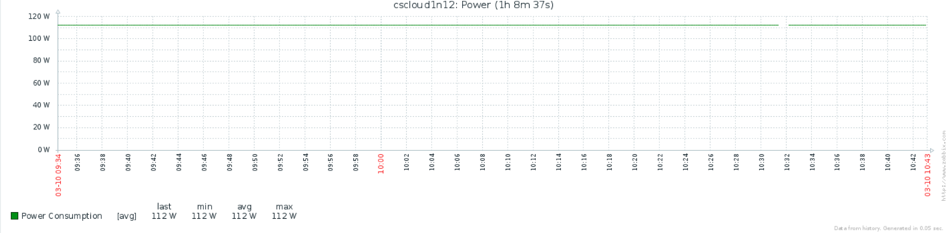

**Power Consumption of 1 Host 2/4 VM**

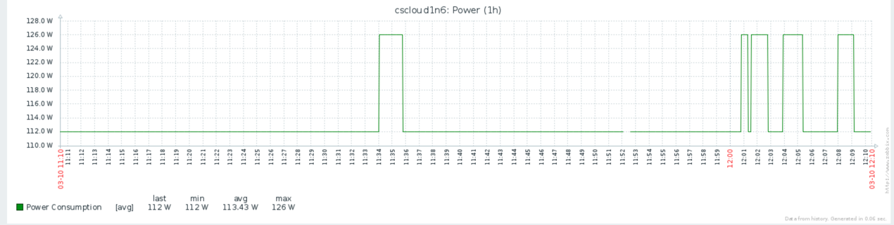

**Power for 2 Host 2 VM**



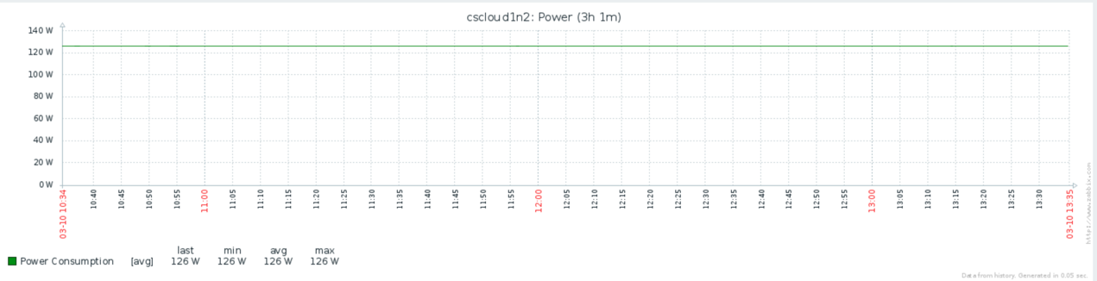

**Power for 4 Host 1 VM**





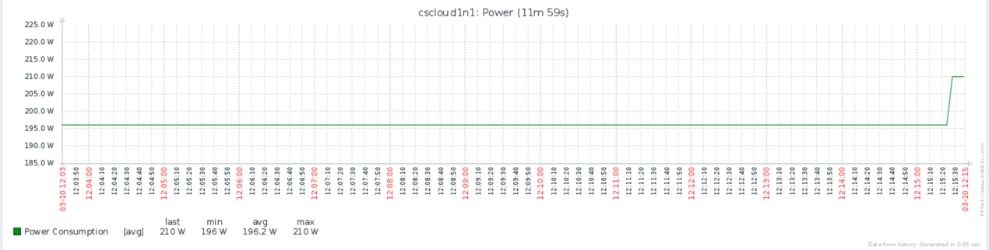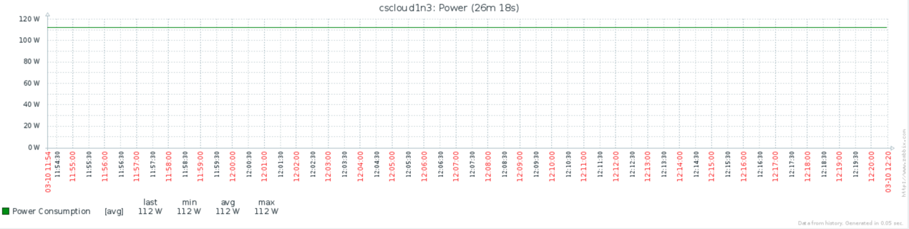

**CPU Usage 1 Host 1 VM Each**

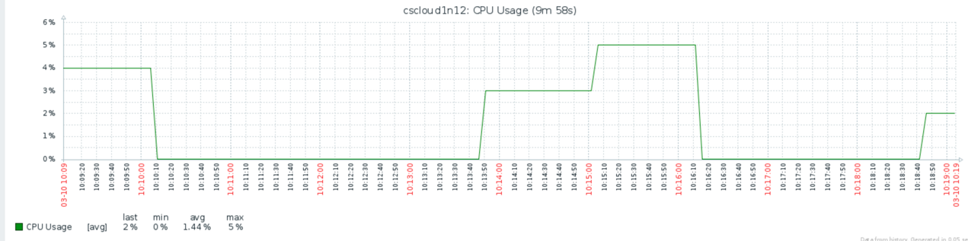

**CPU Usage 1 Host 2 VM Each**

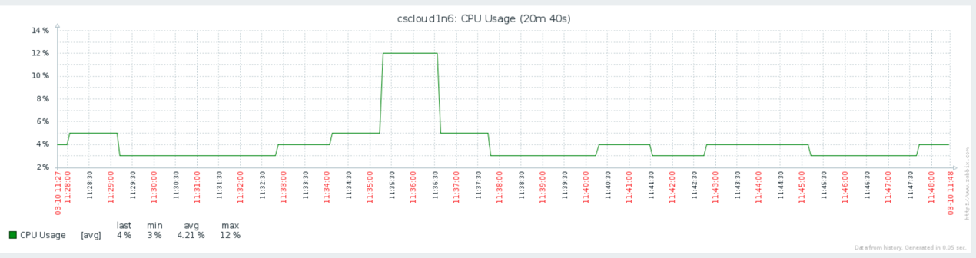

**CPU Usage 2 Host 1 VM Each**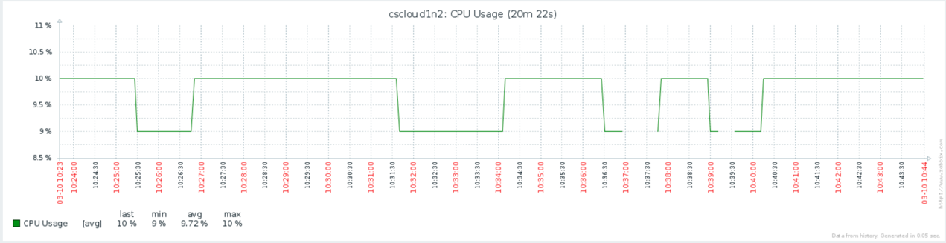

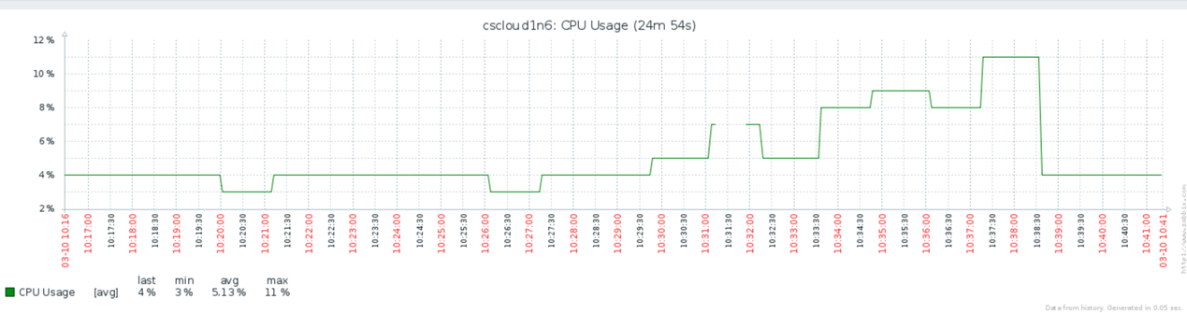

**CPU Usage 4 Host 1 VM Each**

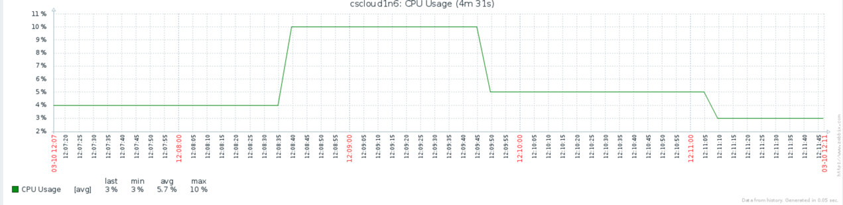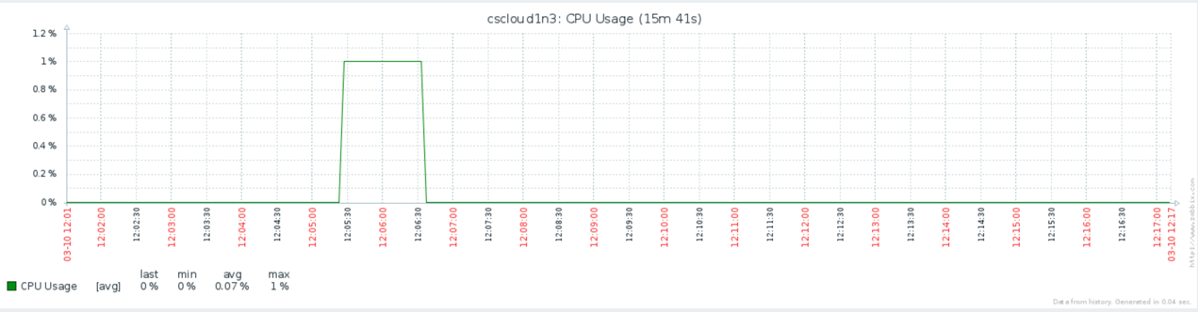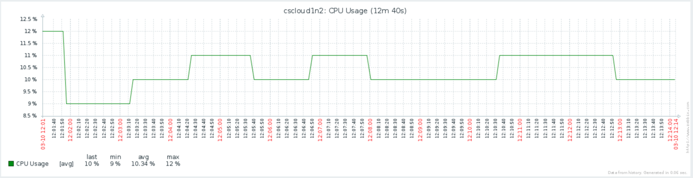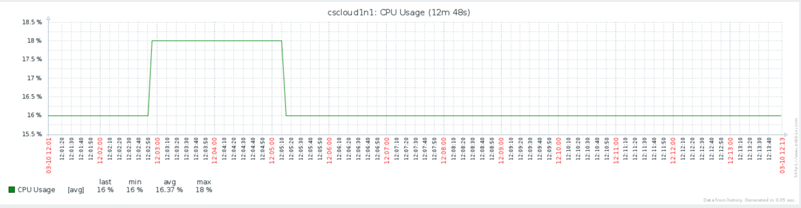

**CPU Usage 2 Host 2 VM Each**

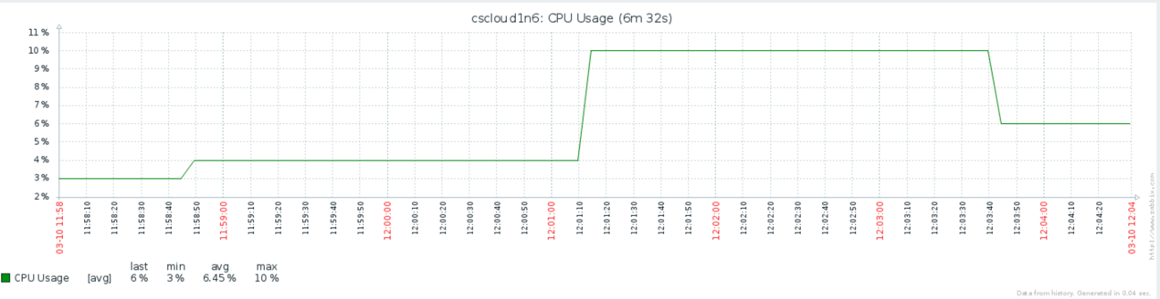

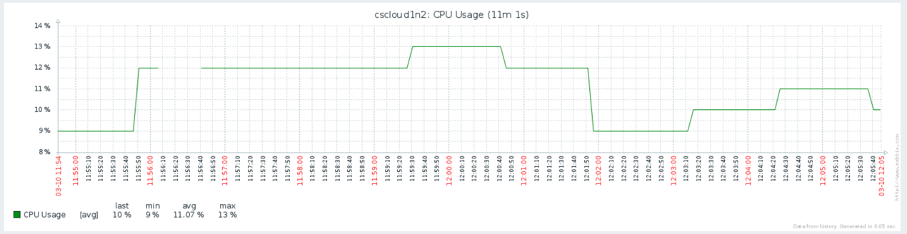

**CPU Usage 1 Host 4 VM Each**

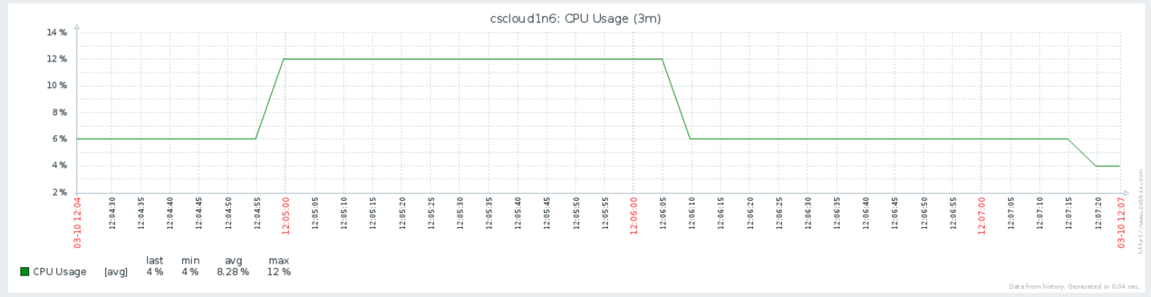

In all of the screenshots, ***cscloud1n6*** is the host with master running. Execution times: 1 host 1 VM: 10:13,

2 host 1 VM: 10:35,

1 host 2 VM: 11:34,

2 host 2 VM: 12:01,

1 host 4 VM: 12:03,

4 host 1 VM: 12:07.

From the screenshots, it is shown that CPU goes up as more VMs are present. The more spread out the VMs, the consumption of each host goes down. As for power, it seems to not be impacted by the different architectures. Power is always more taxing on the master, rather than the slaves. This could be due to the fact that the master is still responsible for the bulk of the computation, also requiring to be a NameNode.

As for time, surprisingly, the best performer was 1 host 4 VM, despite the fact that Hadoop had to copy data over the network, it has still performed the best. This leads to the conclusion that there might be extra overhead when the VMs are all on the same hosts, in terms of being resource starved. The network overhead didn’t seem to have a huge impact, at least comparatively to the sparseness of resources.

It’s worth taking note that the memory usage and network could not be tracked, as they were not available in Zabbix, with memory showing 0 usage throughout. This issue is most likely to do with Zabbix/monitoring infrastructure itself. Furthermore, there are certain times where the power does not spike, as one would expect. This is especially true for the case with 1 host and 1 VM, as you would expect Hadoop would definitely take a toll on the machine. I suspect this might also be due to monitoring errors, although it is possible that the hosts were underloaded, and no visible effect was seen. More likely than not, I would expect the monitoring to be incorrect. In general, there is a lot of noise, especially for CPU usage.

*Evidence of successful run, e.g. screenshot (4 marks)*

I have included .txt files in part-3/hadoop_results which show the run being successful. The times recorded are using the bash script included in part-3/experiments.sh.

**1 Host 1 VM**

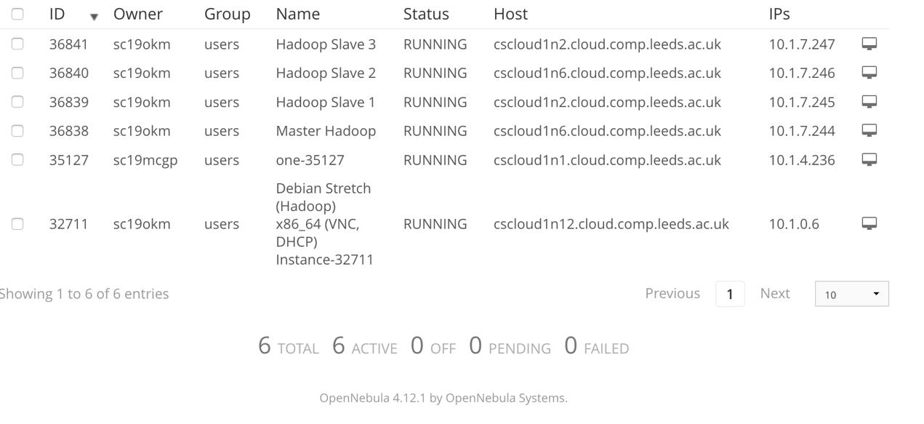

**2 Host 1 VM**

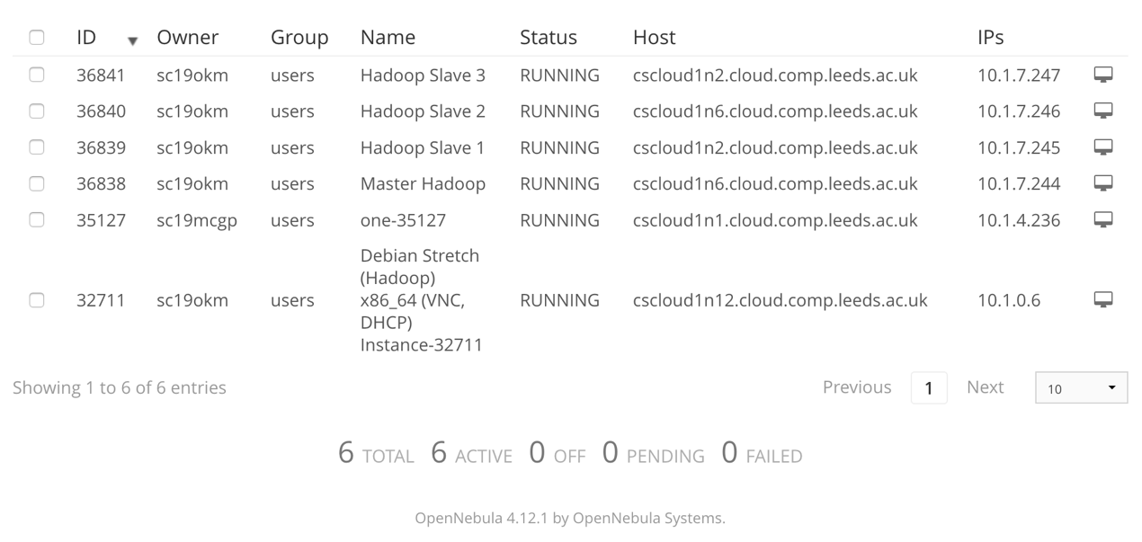

**1 Host 2 VM**

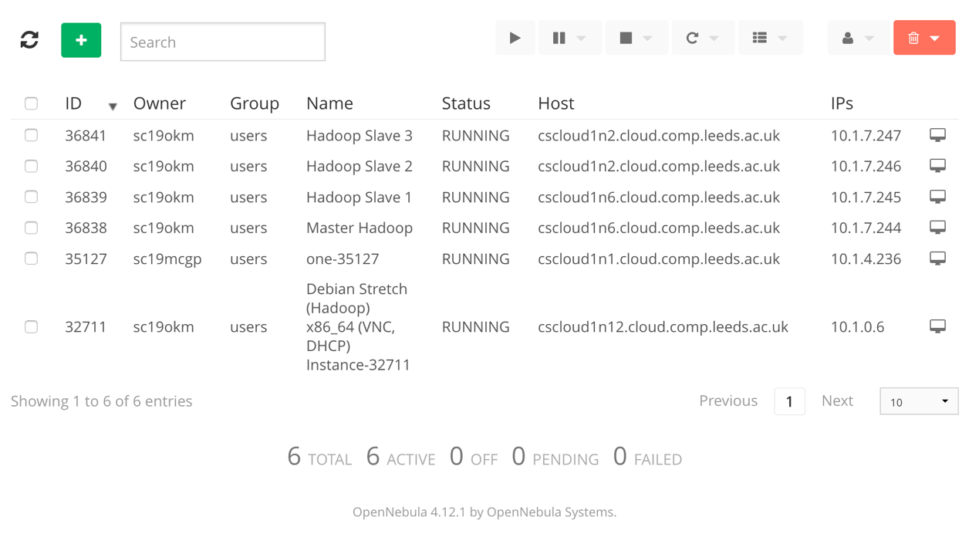

**2 Host 2 VM**



**1 Host 4 VM**

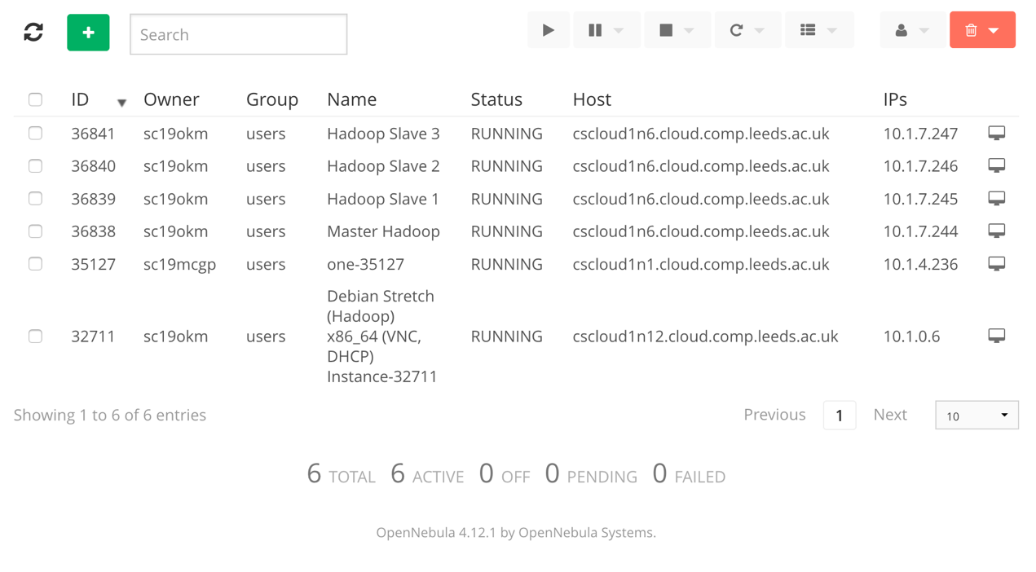

**4 Host 1 VM**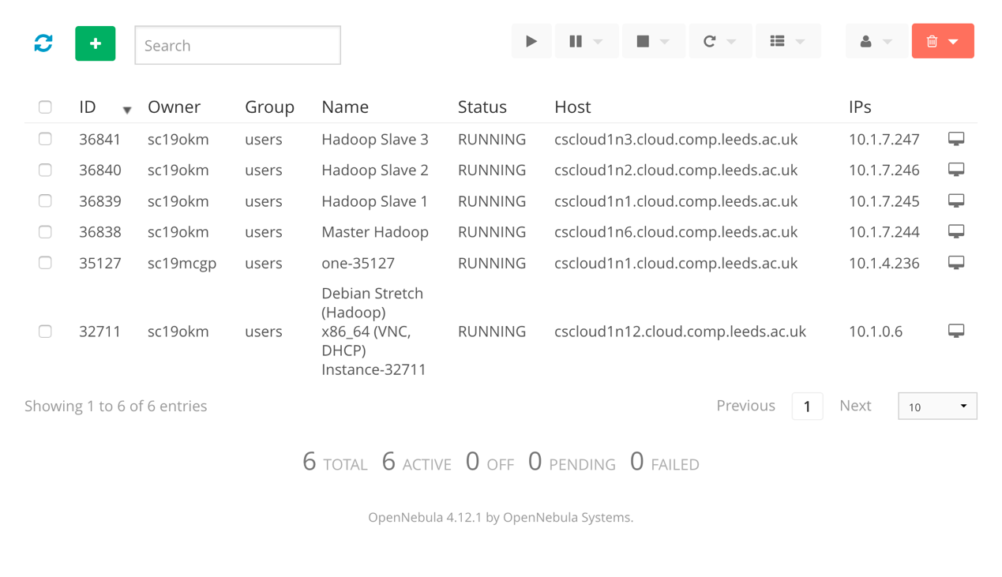

**Any other comments:**